School of Technology

Assessment
Brief

Module Code | Module Title
CMP7005 | Programming for Data Analysis
Academic Year | Semester
2025-2026 | 1

Module Leader email
harshana5000@hotmail.com



Student Details (Student should fill the content)
Name |  |  |  | Fathima Aabidha Rifky
Batch Number |  |  |  | 10
Student ID |  |  |  | Cardiff Met ID : st20357374 |  |  |  |  |  | ICBT ID : CL/MCSDS/CMU/10/04
Scheduled unit details
Unit code |  |  | CMP 7005
Unit title |  |  | Programming for Data Analysis
Assignment Details
Nature of the Assessment |  |  |  |  |  |  | Assignment
Topic of the Case Study |  |  |  |  |  |  | GIVEN
Learning Outcomes covered |  |  |  |  |  |  | YES
Word count |  |  |  |  |  |  | 2800 words
Due date / Time |  |  |  |  |  |  | 23rd April 2026
Declaration
I certify that the attached material is my original work. No other person’s work or ideas have been used without acknowledgement. Except where I have clearly stated that I have used some of this material elsewhere, I have not presented it for examination / assessment in any other course or unit at this or any other institution
Signature |  |  |  |  |  |  |  |  | Date |  | 20-04-2026
Result (Assessor use only)
Marks by 1st Assessor |  |  |  | Name & Signature of the 1st Assessor |  |  |  |  |  |  |  |  |  | Agreed Mark
Marks by IV: |  |  |  | Name & Signature of the IV
For Office use only (hard copy assignments)
Receipt date |  |  |  |  | Received by
Assignment Type & Title:
For student use: Critical feedback on the individual progression towards achieving the assignment outcomes
For 1st Assessor use: Assessment feedback
Strengths

Area for improvements

Name & Signature of the Assessor : |  |  |  |  |  |  |  |  |  |  |  | Date :
Comments by the IV

Name & Signature of the IV: |  |  |  |  |  |  |  |  |  |  |  | Date :

Turnitin Originality Report


Figure 1:Turnitin Originality Report

Screenshot of Submission Details
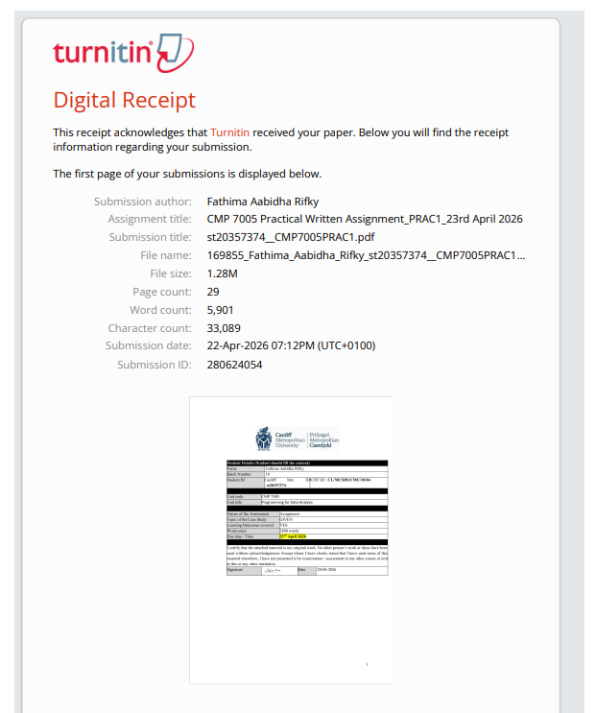
Figure 2: Screenshot of Submission Detail

Acknowledgement
I would like to express my sincere gratitude to my module leader and lecturers for their guidance and support throughout this module. I also acknowledge the authors, organisations, and professional bodies whose publications, standards, and research papers were used as references in preparing this report. Their contributions to the fields of data analytics, machine learning, explainable AI, and educational analytics provided valuable insights and helped strengthen the quality of this work.

List of Abbreviations
AI - Artificial Intelligence
CSV - Comma-Separated Values
EDA - Exploratory Data Analysis
F1-score - Harmonic Mean of Precision and Recall
GUI - Graphical User Interface
ID - Identifier
IQR - Interquartile Range
LR - Logistic Regression
ML - Machine Learning
RF - Random Forest
ROC-AUC - Area Under the Receiver Operating Characteristic Curve

Table of Contents
Turnitin Originality Report iv
Screenshot of Submission Details v
Acknowledgement vi
List of Abbreviations vii
List of Figures xii
ABSTRACT 1
Chapter 1: Introduction 2
1.1 Background to Credit Card Fraud Detection 2
1.1.1 Fraud Detection as an Imbalanced Classification 2
1.2 Problem Context of the Assignment 2
1.2.1 Nature of the Given Dataset and Fraud Target 2
1.3 Aim of the Project 3
1.3.1 Development of a complete Fraud Detection Analysis and Application 3
1.4 Objectives of the project 3
1.5 Structure of the Report 3
Chapter 2: Project Overview and Technical Environment 4
2.1 Overall Project Structure 4
Chapter 3: Data Handling and Dataset Integration 4
3.1 Description of the Source Datasets 4
3.1.1 Credit Card Dataset September Part 1 and Part 2 4
3.2 Data Import and Initial Inspection 4
3.2.1 Loading the CSV Files into the Python Environment 4
3.3 Dataset Merging Strategy 4
3.3.1 Merging on ID and User Using One-to-One Validation 4
3.4 Post-Merge Cleaning and Structural Validation 5
3.4.1 Removal of Redundant Merge Columns and Analytical Dataset Creation 5
3.5 Final Dataset Structure 5
3.5.1 Final Row Count, Column Count, and Variable Categories 5
Chapter 4: EDA and Data Preprocessing 6
4.1 Fundamental Data Understanding 6
4.1.1 Dataset Dimensions, Data Types, and Feature Composition 6
4.2 Target Variable Analysis 6
4.2.1 Fraud and Non-Fraud Distribution 6
4.3 Missing Value Assessment 7
4.3.1 Missingness in Income Type, Years Employed, and Family Size 7
4.4 Data Cleaning and Preparation 7
4.4.1 Handling Missing Values and Data Quality Issues 7
4.5 Feature Engineering 8
4.5.1 Construction of Income Per Person 8
4.6 Univariate Analysis 8
4.6.1 Distribution Analysis of Numerical Features 8
4.6.2 Distribution Analysis of Categorical Features 9
4.7 Bivariate Analysis 10
4.8 Multivariate Analysis 11
4.8.1 Correlation Heatmap and Combined Variable Relationships 11
Chapter 5: ML Model Development and Evaluation 13
5.1 Framing the Prediction Problem 13
5.2 Modelling Dataset Preparation 13
5.3 Preprocessing Pipelines for Machine Learning 14
5.4 Logistic Regression 16
5.5 Random Forest 16
5.6 Evaluation Metrics Used 16
5.7 Comparative Performance of the Base Models 17
5.8 Model Improvement and Threshold Tuning 17
5.9 Final Model Selection 18
5.10 Feature Importance Analysis 18
5.10.1 Most Influential Variables in the Final Model 18
Chapter 6: GUI Application Design and Implementation 20
6.1 Flask Application Structure and Pages 20
6.2 Prediction Workflow 22
Chapter 7: Version Control and Development Progress 24
7.1 Version Control and Development Progress 24
Chapter 8: Critical Evaluation 25
8.1 Strengths of the Project 25
8.2 Limitations and Practical Considerations 25
Chapter 9: Conclusion and Recommendations 27
9.1 Conclusion 27
9.2 Recommendations 28
REFERENCES 29
APPENDICES 30
Appendix A – Additional Model Evidence 30
Appendix B - Confusion matrix for the final tuned model 31
Appendix C – Github Link 31
Appendix D – Onedrive Link 31

List of Figures
Figure 1:Turnitin Originality Report iv
Figure 2: Screenshot of Submission Details v
Figure 3 : Merge quality summary for the two source datasets. 5
Figure 4 : Class distribution of the TARGET variable in the merged dataset. 6
Figure 5 : Missing values detected before preprocessing 7
Figure 6 : Overall histogram view of numerical features after preprocessing 9
Figure 7 : Distribution of INCOME_PER_PERSON after feature engineering and preprocessing 9
Figure 8 : Distribution of major categorical variables in the cleaned dataset 10
Figure 9 : AGE by target class using boxplots 11
Figure 10 : Income type versus fraud status. 11
Figure 11 : Correlation heatmap for the cleaned analytical dataset 12
Figure 12 : Precision, recall, and F1-score across candidate thresholds for the tuned Random Forest 13
Figure 13 : Top threshold candidates ranked by F1-score 14
Figure 14 : ROC curve for the final tuned Random Forest 14
Figure 15 : Precision-recall curve for the final tuned Random Forest 15
Figure 16 : Top 10 feature importance values from the final tuned Random Forest 15
Figure 17 : Comparison of baseline and tuned model performance. 17
Figure 18 : Home page of the Flask fraud detection application 20
Figure 19 : Data overview page showing dataset structure and feature schema 21
Figure 20 : EDA page displaying saved visual outputs from the notebook 21
Figure 21 : Prediction page with model selector, input form, and performance metrics panel 22
Figure 22 : Prediction output showing fraud probability, risk level, and system recommendation 23
Figure 23 : Git commit history showing the main stages of project development 24
Figure 24 : Classification report for the final tuned model at the default decision threshold 30
Figure 25 : Confusion matrix for the final tuned model at the optimised threshold (0.44898) 31

ABSTRACT
This project develops a full fraud detection workflow for a merged credit card dataset and then turns that work into a simple Flask based web application. The analysis begins with importing and merging two source files using the shared identifiers ID and User. After the merge, the analytical dataset contained 25,134 records and 19 columns. Exploratory data analysis showed that the target class was highly imbalanced, with only 422 fraudulent cases, which made the modelling stage more challenging. The preprocessing stage handled small amounts of missing data, removed constant and non-predictive fields, capped outliers using the IQR rule, and created one derived feature called INCOME_PER_PERSON. For model building, the notebook compared Logistic Regression, Decision Tree, Random Forest, and Gradient Boosting, while the main written discussion focused on Logistic Regression and Random Forest because these are the two chosen models in line with the brief. Random Forest clearly performed better overall. A further tuning step using RandomizedSearchCV produced the final selected model, and threshold analysis showed that a cut-off near 0.45 gave a small but useful improvement in fraud detection balance. Finally, the project was deployed as a multi-page Flask application with Overview, EDA, and Prediction pages, supported by Git and GitHub for version control.
This demonstrates the practical deployment of machine learning models within a real-world decision-support context. This demonstrates how machine learning models can be effectively translated into practical decision-support systems in real-world financial contexts.

Chapter 1: Introduction

1.1 Background to Credit Card Fraud Detection

1.1.1 Fraud Detection as an Imbalanced Classification
Credit card fraud detection represents a typical example of an imbalanced classification problem. In this kind of task, the number of normal cases is much larger than the number of fraud cases, so a model can look accurate even when it misses many of the rare events that actually matter. That is why fraud prediction usually cannot be judged by accuracy alone (He and Garcia, 2009; Makki et al., 2019). Measures such as precision, recall, F1-score and the precision-recall trade-off become much more important when the minority class is the one the analyst really cares about (He and Garcia, 2009; Makki et al., 2019).
In this project, the fraud problem is approached through a full pipeline rather than a single model. The work starts from raw CSV files, moves through cleaning and exploratory analysis, then builds predictive models, and finally deploys the selected models through a simple web interface. This makes the project closer to a practical workflow than a notebook-only exercise.

1.2 Problem Context of the Assignment

1.2.1 Nature of the Given Dataset and Fraud Target
The source data comes from two files, Credit_Card_Dataset_2025_Sept_1.csv and Credit_Card_Dataset_2025_Sept_2.csv, which were merged into one analytical dataset. After merging and removing redundant columns, the dataset contained 25,134 rows and 19 columns. The target variable was binary, where 1 represented fraud and 0 represented non-fraud. A quick check of the class distribution showed 24,712 normal cases and 422 fraud cases, which means the fraud rate was only 1.679%. That imbalance shaped almost every decision in the project, especially the way model performance was interpreted (Makki et al., 2019; Afriyie et al., 2023).
The project therefore required not only prediction, but a full workflow from dataset integration to model deployment

1.3 Aim of the Project

1.3.1 Development of a complete Fraud Detection Analysis and Application
The aim of this project was to build a complete fraud detection solution that could handle the given datasets, analyse them properly, train suitable machine learning models, and present the final output through a multipage graphical interface. The aim was not just technical correctness, but also to show clear understanding of the dataset and to produce results that make sense for an imbalanced fraud setting.

1.4 Objectives of the project
The project had five linked objectives: to merge the two datasets correctly, analyse and clean the merged data, build and compare suitable classification models, create a multipage Flask application for dataset viewing and prediction, and manage the work using Git and GitHub.

1.5 Structure of the Report
This report follows the main stages of the project from data handling to deployment. It begins with dataset integration and exploratory analysis, then moves to model development and the Flask application. The final chapters cover version control, critical evaluation, and the overall conclusion.

Chapter 2: Project Overview and Technical Environment

2.1 Overall Project Structure
The repository is divided into two main parts. The notebook/ folder contains the datasets, analysis notebook, generated figures and tables, saved models, and other output files produced during the analytical stage. The src/ folder contains the Flask application, including the backend file, HTML templates, and static resources used for the web interface. This structure clearly separates the analysis work from the deployment layer and makes the project easier to manage.

Chapter 3: Data Handling and Dataset Integration

3.1 Description of the Source Datasets

3.1.1 Credit Card Dataset September Part 1 and Part 2
The analysis began with two CSV files that were later merged into one working dataset. The first file contained 25,134 rows and 17 columns and included most of the customer, household, contact, and target related variables. The second file also contained 25,134 rows, but only 4 columns, and mainly added income, income type, education type, and the secondary merge key. This means the two files were complementary, with the second file supplying extra attributes needed to complete the main analytical dataset.

3.2 Data Import and Initial Inspection

3.2.1 Loading the CSV Files into the Python Environment
The notebook loaded both files using pandas.read_csv(). Before merging, the code printed each file’s shape and columns. This was a good first step because it confirmed that both files had the same number of rows and that the merge keys were present. It also made it easy to see which variables belonged to which source.

3.3 Dataset Merging Strategy

3.3.1 Merging on ID and User Using One-to-One Validation
The merge was done with pd.merge() using left_on="ID" and right_on="User", how="outer", and validate="one_to_one". The one-to-one validation is an important detail because it checks that each record in one file matches at most one record in the other. That gave extra confidence that the merge did not silently duplicate rows. After merging, the raw merged dataset had 25,134 rows and 21 columns. The redundant columns User and Unnamed: 0 were then removed, leaving the final analytical dataset with 25,134 rows and 19 columns.
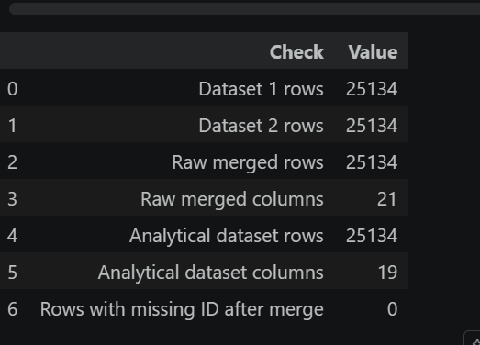
Figure 3 : Merge quality summary for the two source datasets.

3.4 Post-Merge Cleaning and Structural Validation

3.4.1 Removal of Redundant Merge Columns and Analytical Dataset Creation
After the merge, the code checked for missing ID values and found none. That was important because any missing identifier after merge would suggest unmatched or broken records. The project then moved from the raw merged data to the analytical dataset by removing non-analytical columns. This step kept only the fields relevant for later analysis and modelling.

3.5 Final Dataset Structure

3.5.1 Final Row Count, Column Count, and Variable Categories
After merge cleanup, the analytical dataset contained 19 columns. It included a mix of numerical and categorical variables. Initial inspection also showed that FLAG_MOBIL had only one unique value, while the main missing values were found in INCOME_TYPE, YEARS_EMPLOYED, and FAMILY SIZE.

Chapter 4: EDA and Data Preprocessing

4.1 Fundamental Data Understanding

4.1.1 Dataset Dimensions, Data Types, and Feature Composition
The first stage of EDA focused on understanding the structure of the merged dataset. After merge cleanup, the dataset contained 25,134 rows and 19 columns. It included a mix of numerical and categorical variables, with fields such as INCOME, AGE, YEARS_EMPLOYED, and BEGIN_MONTH stored as numerical values, while fields such as GENDER, INCOME_TYPE, HOUSE_TYPE, and EDUCATION_TYPE were categorical.
The unique value checks also helped identify variables that might not be useful for modelling. In particular, FLAG_MOBIL had only one unique value, which meant it had no variation and therefore no predictive value. This was flagged early and later removed during preprocessing.

4.2 Target Variable Analysis

4.2.1 Fraud and Non-Fraud Distribution
The target variable was highly imbalanced. The dataset contained 24,712 non-fraud cases and 422 fraud cases, meaning fraud represented only 1.679% of the data. This was an important finding because it meant that model evaluation could not rely on accuracy alone. In a dataset like this, a model can achieve a high accuracy score even if it performs poorly on the minority fraud class.
In imbalanced settings like this, the minority class is the important one, so measures like recall and F1-score need more attention than accuracy by itself (He and Garcia, 2009; Makki et al., 2019).
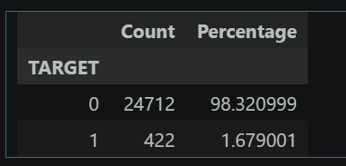
Figure 4 : Class distribution of the TARGET variable in the merged dataset.

4.3 Missing Value Assessment

4.3.1 Missingness in Income Type, Years Employed, and Family Size
The missing value analysis showed only a small amount of missing data. INCOME_TYPE had 12 missing values, YEARS_EMPLOYED had 9, and FAMILY SIZE had 1. Although the missingness was very low in percentage terms, it still needed to be handled before modelling so that the pipeline could run without errors.

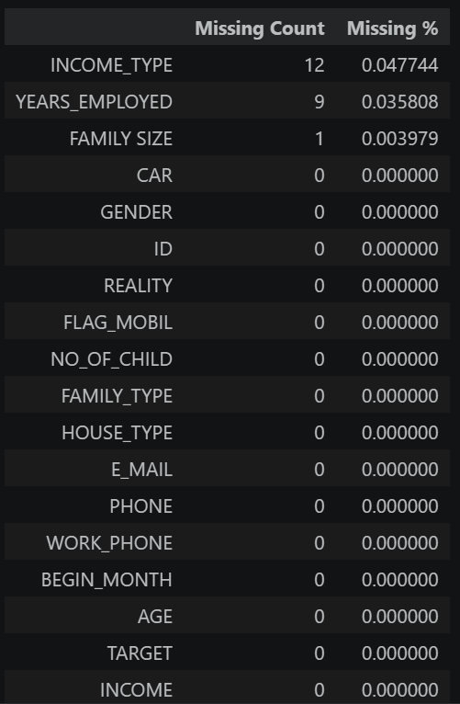
Figure 5 : Missing values detected before preprocessing

4.4 Data Cleaning and Preparation

4.4.1 Handling Missing Values and Data Quality Issues
The notebook first checked for duplicate rows and found none. Numerical missing values were imputed with the median and categorical missing values with the mode. After imputation, the dataset had no remaining missing values.
The preprocessing stage then removed the constant column FLAG_MOBIL. Later, ID and E_MAIL were also dropped before modelling because ID was only an identifier and E_MAIL was not retained as a useful predictive field in the notebook workflow. By the end of this stage, the cleaned modelling dataset contained 25,134 rows and 17 columns.

4.5 Feature Engineering

4.5.1 Construction of Income Per Person

The main engineered feature created in the notebook was INCOME_PER_PERSON, calculated as INCOME / FAMILY SIZE. To avoid division issues, zero family size values were replaced with 1 during the calculation. This feature was included because total income alone may not reflect the financial burden within a household.
This turned out to be a useful addition, since INCOME_PER_PERSON later appeared among the more important features in the final model. The final modelling dataset included numerical variables such as age, begin month, years employed, income, and income per person, together with categorical variables such as gender, income type, house type, family type, reality, and education type.

4.6 Univariate Analysis

4.6.1 Distribution Analysis of Numerical Features
The numerical univariate analysis was used to inspect the shape and spread of the main continuous and count-based variables. The plots showed that INCOME and INCOME_PER_PERSON were clearly right-skewed, with most records concentrated in lower ranges and a smaller number of much higher values. This pattern is common in income related variables and shows that these features had wide variation across customers.
Other variables were more concentrated. AGE was centred around middle adulthood, while YEARS_EMPLOYED was mostly grouped in the lower and middle ranges. FAMILY SIZE was concentrated around small households, mainly between one and three members, and NO_OF_CHILD was also mostly clustered at lower values. These patterns gave a clearer view of the dataset before modelling and supported the later preprocessing pipeline.
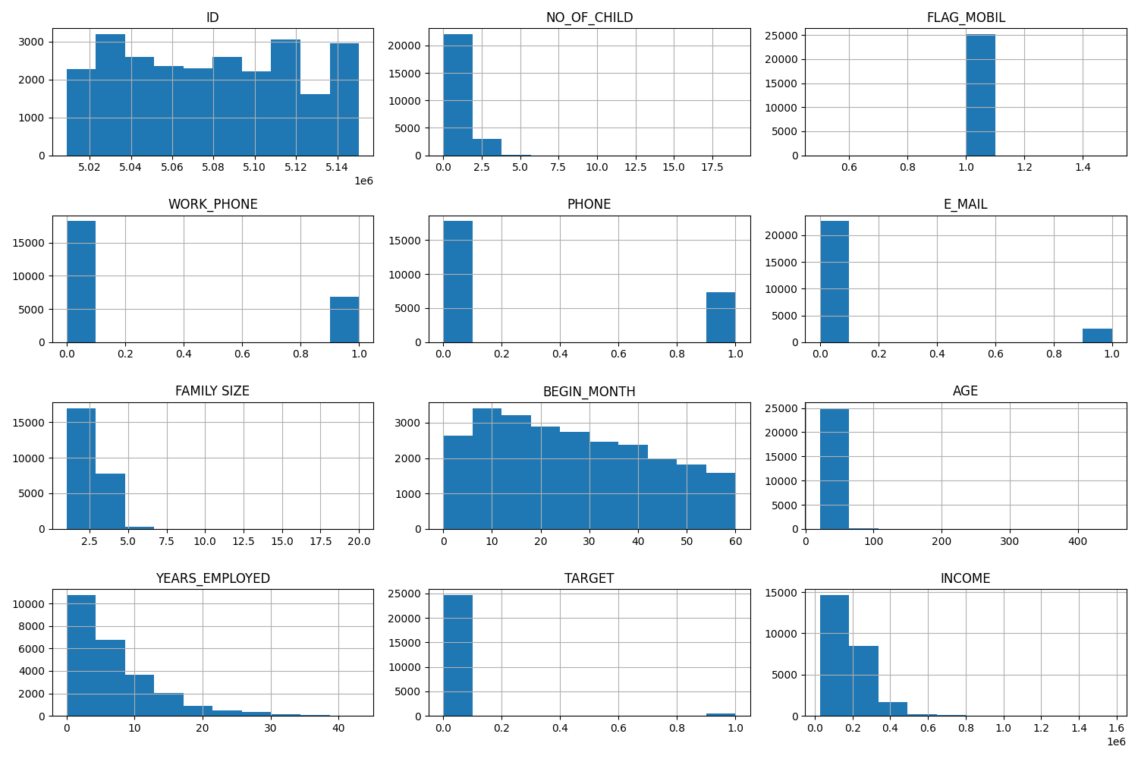
Figure 6 : Overall histogram view of numerical features after preprocessing
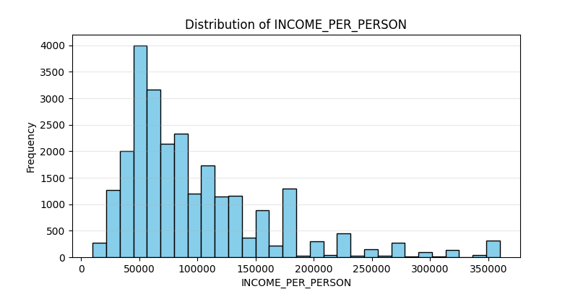
Figure 7 : Distribution of INCOME_PER_PERSON after feature engineering and preprocessing

4.6.2 Distribution Analysis of Categorical Features
The univariate analysis of categorical variables showed that some categories appeared much more frequently than others. In HOUSE_TYPE, the category House / apartment made up the large majority of records. In INCOME_TYPE, the most common category was Working, while in EDUCATION_TYPE, Secondary / secondary special appeared most often.
These patterns showed that the categorical variables were not evenly distributed across classes. This was important because uneven category frequencies can affect model learning, especially when the target class is also imbalanced. It also supported the use of one-hot encoding in the preprocessing pipeline, since these variables contained multiple nominal groups.
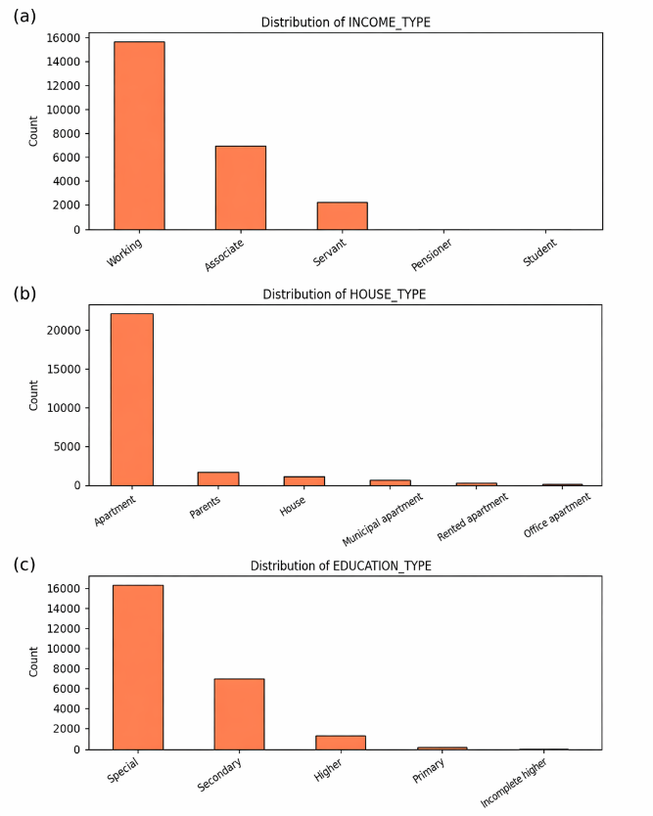
Figure 8 : Distribution of major categorical variables in the cleaned dataset

4.7 Bivariate Analysis
For the numerical variables, the notebook used boxplots grouped by TARGET to compare fraud and non-fraud cases. The visual differences were not equally strong for every feature, but BEGIN_MONTH, AGE, YEARS_EMPLOYED, and INCOME_PER_PERSON showed patterns that were useful later in the modelling stage. This is consistent with the later feature importance results from the final model.
For the categorical variables, the notebook used grouped or stacked charts to compare class counts across categories. Some small differences in fraud rate were visible. Males had a slightly higher fraud rate than females, records marked N under REALITY showed a somewhat higher fraud rate than Y, and some family groups such as widows and single individuals showed slightly higher fraud proportions than married cases. These patterns were not strong enough to be treated as standalone predictors, but they did help provide context for the modelling stage.

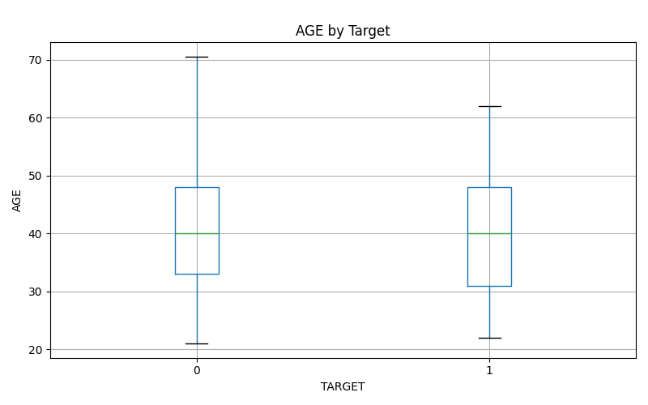
Figure 9 : AGE by target class using boxplots

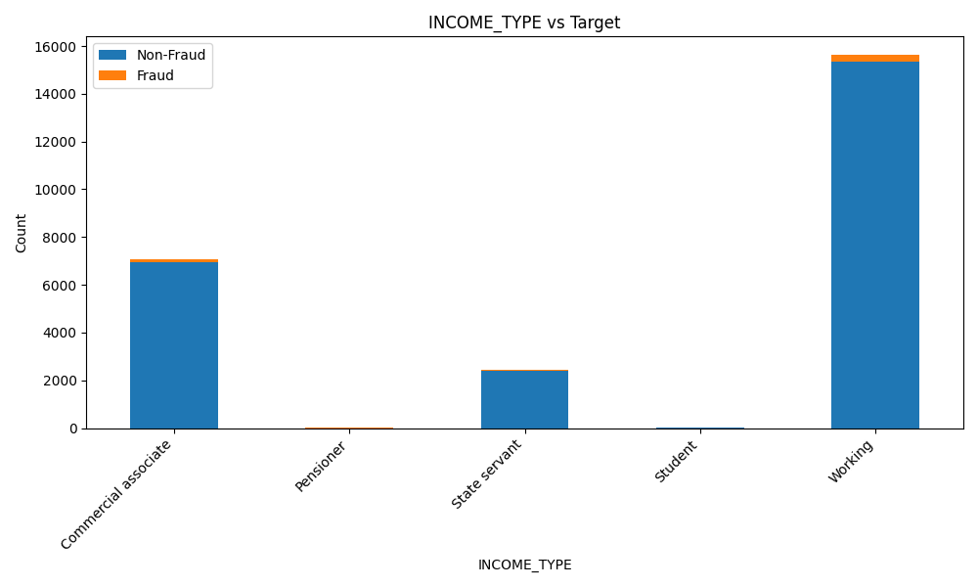
Figure 10 : Income type versus fraud status.

4.8 Multivariate Analysis

4.8.1 Correlation Heatmap and Combined Variable Relationships
The notebook also generated a numerical correlation heatmap to examine relationships across variables. The strongest positive correlation with the target was BEGIN_MONTH at about 0.061, while YEARS_EMPLOYED showed a small negative correlation of about -0.033. Overall, the correlations with the target were weak.
The weak linear correlations suggest that fraud is not driven by one single variable, which supports the later use of a non-linear ensemble model (Makki et al., 2019; Afriyie et al., 2023). Overall, the EDA stage confirmed strong class imbalance, light missingness, useful engineered income information, and the need for a mixed preprocessing pipeline.
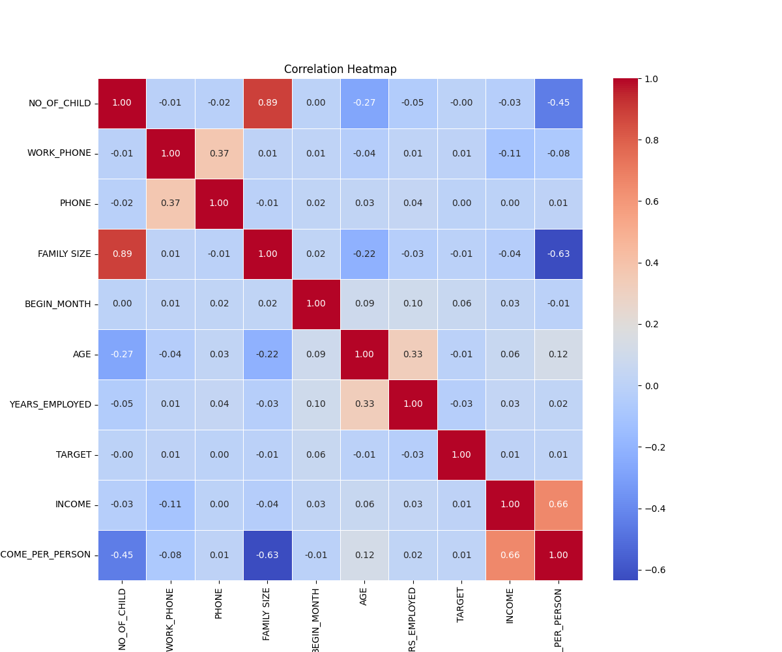Figure 11 : Correlation heatmap for the cleaned analytical dataset

Chapter 5: ML Model Development and Evaluation

5.1 Framing the Prediction Problem
The project treats fraud detection as a binary classification problem because the target variable takes only two values, 0 and 1 (He and Garcia, 2009; Makki et al., 2019). This is also clear from the code and the evaluation measures used in the notebook, including precision, recall, F1-score, ROC-AUC, confusion matrices, ROC curves, and precision-recall curves. Even though the brief mentions regression once, the actual implementation and dataset structure clearly show that this is a classification task.
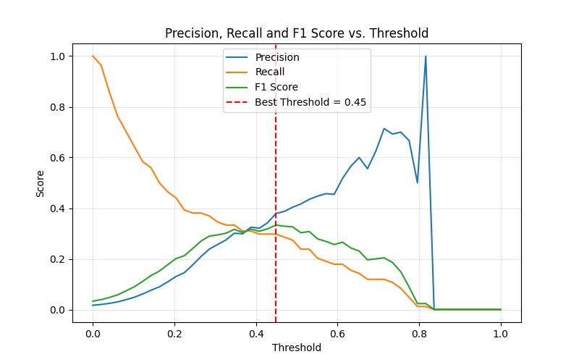
Figure 12 : Precision, recall, and F1-score across candidate thresholds for the tuned Random Forest

5.2 Modelling Dataset Preparation
For modelling, the notebook defined X as the feature set and y as the TARGET column. The dataset was split using an 80:20 train-test split with random_state=42 and stratify=y, so that the class ratio remained similar in both sets. This produced 20,107 training records and 5,027 test records. Since fraud was rare, stratification was important to make sure the minority class was still represented properly during evaluation.
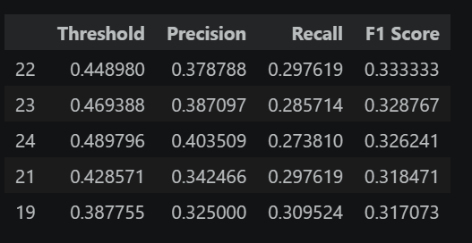
Figure 13 : Top threshold candidates ranked by F1-score
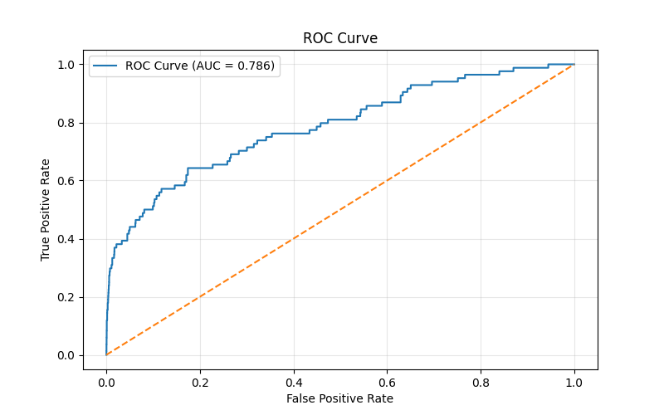
Figure 14 : ROC curve for the final tuned Random Forest

5.3 Preprocessing Pipelines for Machine Learning
A shared preprocessing pipeline was created before training the benchmark models. Numerical variables were handled using median imputation and scaling, while categorical variables were handled using most-frequent imputation and one-hot encoding with unknown categories ignored. This kept all transformations inside the modelling pipeline and ensured that the same preprocessing logic was applied consistently to both training data and unseen test data.
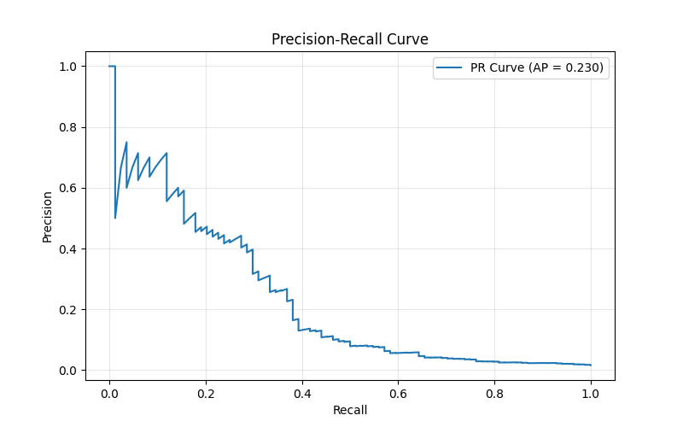
Figure 15 : Precision-recall curve for the final tuned Random Forest
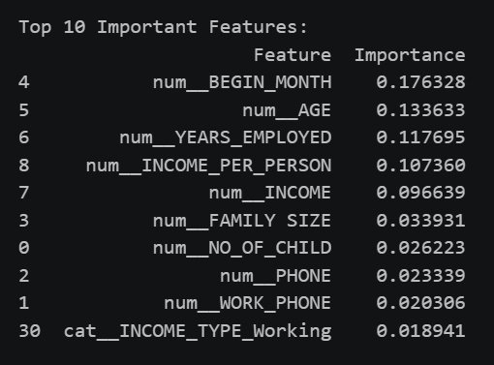
Figure 16 : Top 10 feature importance values from the final tuned Random Forest
The use of a pipeline-based modelling approach ensures that all preprocessing steps are applied consistently and prevents data leakage. Data leakage occurs when information from the test set influences the training process, leading to overly optimistic performance estimates.

By embedding imputation, scaling, and encoding within the pipeline, transformations are learned only from the training data and then applied to the test data. This guarantees that model evaluation reflects true generalisation performance on unseen data.

5.4 Logistic Regression
Logistic Regression was used as the first main model because it provides a clear baseline and is commonly included in fraud detection comparisons (Afriyie et al., 2023; Makki et al., 2019). In the notebook, it was configured with max_iter=1000 and class_weight="balanced" to account for the strong class imbalance. The model achieved high recall of 0.595, which means it identified many fraud cases, but its precision was only 0.027. This shows that it produced too many false positives. Its F1-score was 0.052, so even though it was sensitive to fraud, the overall balance was weak.

5.5 Random Forest
Random Forest was used as the second main model because it is better suited to capturing non-linear relationships across mixed features and structured fraud data and has shown strong performance in previous fraud detection studies (Makki et al., 2019; Afriyie et al., 2023). The baseline Random Forest used class_weight="balanced" and random_state=42. It achieved an accuracy of 0.9829, precision of 0.4706, recall of 0.1905, F1-score of 0.2712, and ROC-AUC of 0.7338. Compared with Logistic Regression, it produced far fewer false positives, although it also detected fewer fraud cases. This made it a more balanced starting point for further tuning.

5.6 Evaluation Metrics Used
Accuracy was reported, but it was not used alone because the data were highly imbalanced. Precision, recall, and F1-score were more important for judging fraud detection quality, while ROC-AUC was used to assess ranking performance across thresholds (He and Garcia, 2009; Makki et al., 2019).
Among the evaluation metrics, F1-score was treated as the most important performance indicator. This is because fraud detection requires a balance between correctly identifying fraudulent cases (recall) and avoiding excessive false positives (precision).
A model with high recall but very low precision would generate too many false alarms, making it impractical. Conversely, a model with high precision but low recall would fail to detect many fraud cases, which is risky in real-world applications.
Therefore, F1-score provides the most meaningful measure of overall performance in this imbalanced classification problem.

5.7 Comparative Performance of the Base Models
The notebook tested four baseline models in total, including Decision Tree and Gradient Boosting, but the main discussion here focuses on Logistic Regression and Random Forest to match the assignment brief. The comparison between these two models showed a clear trade-off. Logistic Regression achieved much higher recall, but its precision collapsed, meaning that many normal cases were incorrectly flagged as fraud. Random Forest, on the other hand, was more selective and gave much stronger precision, but its recall was lower.
This difference is important in fraud detection. A model that catches more fraud can still be impractical if it produces too many false positives. On the other hand, a model with strong precision may still be too weak if it misses too many fraud cases. Based on the baseline comparison, Random Forest was the stronger overall model because it gave a more useful balance before further tuning.
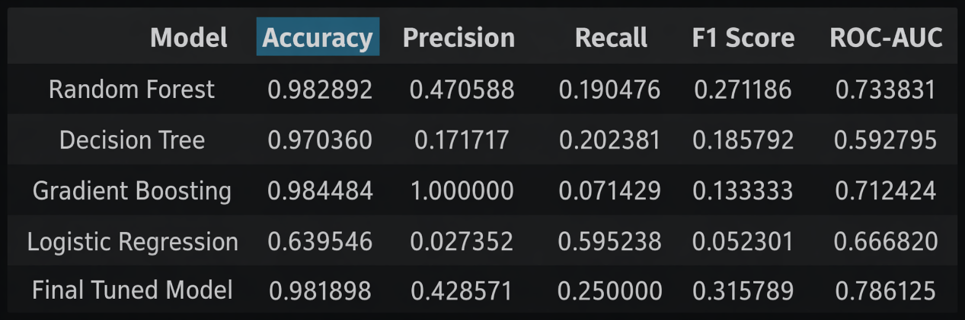
Figure 17 : Comparison of baseline and tuned model performance.
This kind of trade-off is common in imbalanced fraud detection, where improving sensitivity to the minority class often reduces precision (Makki et al., 2019; Zhu et al., 2020).

5.8 Model Improvement and Threshold Tuning
After the baseline comparison, the notebook improved the Random Forest model using RandomizedSearchCV. The search tested different combinations of n_estimators, max_depth, min_samples_split, and min_samples_leaf. The best parameter set was n_estimators=300, max_depth=20, min_samples_split=5, and min_samples_leaf=4. This tuned model was then saved as the final selected model.
Further tuning was necessary because imbalanced fraud detection often requires more than a default model fit, especially when the goal is to improve the balance between recall and precision (Zhu et al., 2020; Huang et al., 2024).
Threshold adjustment is especially useful in fraud problems because the default cut-off does not always reflect the best trade-off for minority-class detection (Zhu et al., 2020; Huang et al., 2024).
At the default threshold, the tuned Random Forest achieved precision of 0.43, recall of 0.25, F1-score of 0.32, and ROC-AUC of 0.786. The notebook then carried out threshold tuning using the probability outputs of the tuned model. The best threshold was 0.44898, or approximately 0.45. At that threshold, precision became 0.379, recall increased to 0.298, and F1-score increased to 0.333. This shows that a small change in threshold improved the balance between catching fraud and controlling false positives.

5.9 Final Model Selection
The tuned Random Forest model was selected as the final model because it provided the best overall balance between precision and recall. While Logistic Regression achieved higher recall, its extremely low precision resulted in excessive false positives, making it impractical for deployment.
In contrast, the tuned Random Forest achieved a stronger F1-score and the highest ROC-AUC among the evaluated models, indicating better overall classification performance and ranking ability. After hyperparameter tuning and threshold optimisation, the model demonstrated improved fraud detection capability while maintaining acceptable precision.
Therefore, the tuned Random Forest was selected as the most suitable model for deployment, as fraud detection systems require a balanced trade-off between detecting fraudulent cases and minimising false alerts.
This selection is consistent with prior research, which shows that ensemble methods outperform linear models in complex, imbalanced classification tasks.

5.10 Feature Importance Analysis

5.10.1 Most Influential Variables in the Final Model
The feature importance results helped explain what the final model relied on most. The top variables were BEGIN_MONTH, AGE, YEARS_EMPLOYED, INCOME_PER_PERSON, and INCOME. These results suggest that time-related account behaviour, employment history, and household-adjusted income were more informative than many of the simple binary fields. The strong position of INCOME_PER_PERSON also supports the earlier feature engineering step, since it shows that household-level income context added useful predictive value to the model.

Chapter 6: GUI Application Design and Implementation

6.1 Flask Application Structure and Pages
The deployment layer of the project was built using Flask, with the main backend logic placed in src/app.py and the interface created through HTML templates in src/templates/, supported by static files in src/static/. The application is organised around four main pages: Home, Overview, EDA, and Prediction. The Home page introduces the system and the available models, the Overview page presents dataset information and feature details, the EDA page displays saved analytical figures from the notebook, and the Prediction page allows the user to enter inputs and generate a fraud prediction. This structure keeps the web application simple while still covering the main requirements of the assignment. The design also reflects the overall project workflow, because the notebook performs the main analytical work and the Flask app presents the saved outputs in a more accessible form.
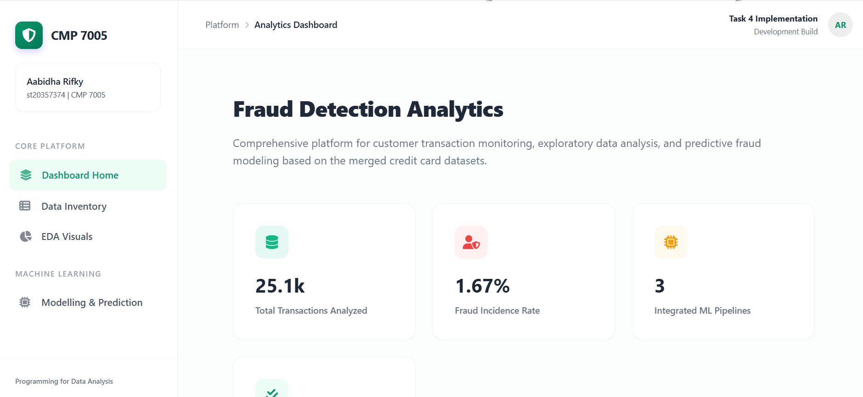
Figure 18 : Home page of the Flask fraud detection application
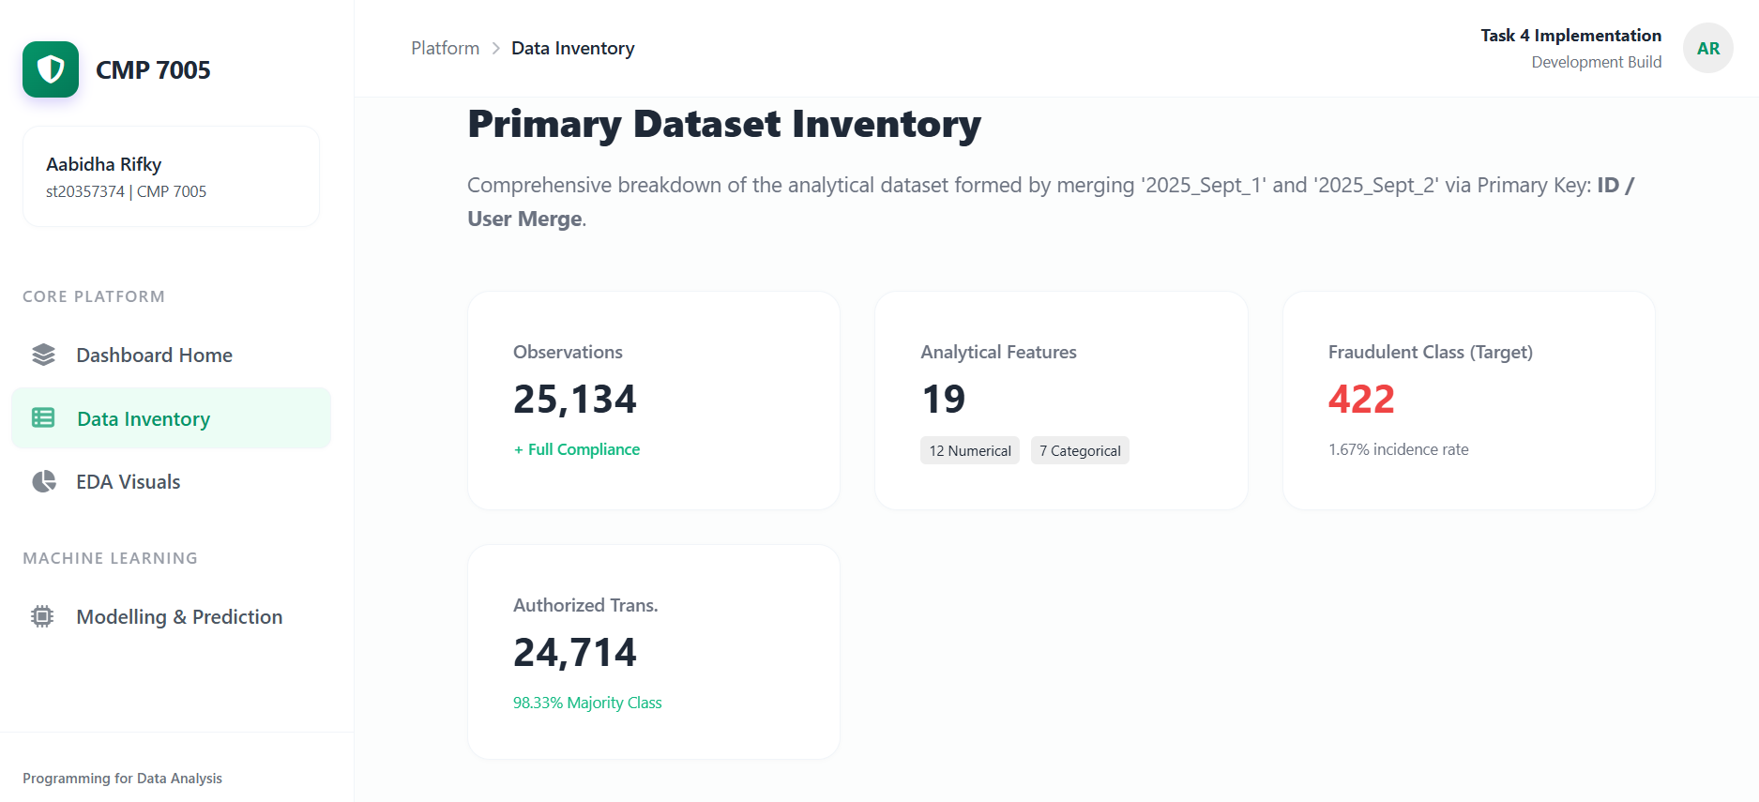
Figure 19 : Data overview page showing dataset structure and feature schema

Figure 20 : EDA page displaying saved visual outputs from the notebook
The Flask framework was selected due to its lightweight architecture and flexibility for rapid deployment of machine learning models. It allows seamless integration between backend model logic and frontend user interfaces.
The application loads pre-trained pipeline models rather than raw models, ensuring that all preprocessing steps (imputation, scaling, encoding) are applied consistently during prediction. This approach maintains alignment between training and deployment environments, reducing the risk of data inconsistencies.
The inclusion of multiple models within the interface enables comparative analysis, allowing users to observe differences in predictive behaviour across algorithms. This improves transparency and supports interpretability of model performance.

6.2 Prediction Workflow
The prediction page is the main interactive part of the application. It allows the user to choose between three saved models: Logistic Regression, Random Forest, and Final Tuned Model (RF). The form collects visible inputs such as gender, age, income, income type, years employed, begin month, family size, and house type. To keep the form shorter, the backend fills several additional fields with default values before prediction, including CAR, REALITY, NO_OF_CHILD, FAMILY_TYPE, WORK_PHONE, PHONE, and EDUCATION_TYPE. It also calculates INCOME_PER_PERSON before sending the record to the selected model.
After submission, the selected model is loaded and used to generate both a predicted class and a fraud probability. The output is then shown in a more readable format with the prediction result, probability, risk level, and a short recommendation message. The page also displays stored validation metrics for the selected model using the saved comparison table. The web application loads the saved final model and displays stored validation metrics, while the threshold optimisation itself was performed in the notebook stage. The Flask app also includes basic error handling for prediction failures and invalid routes.
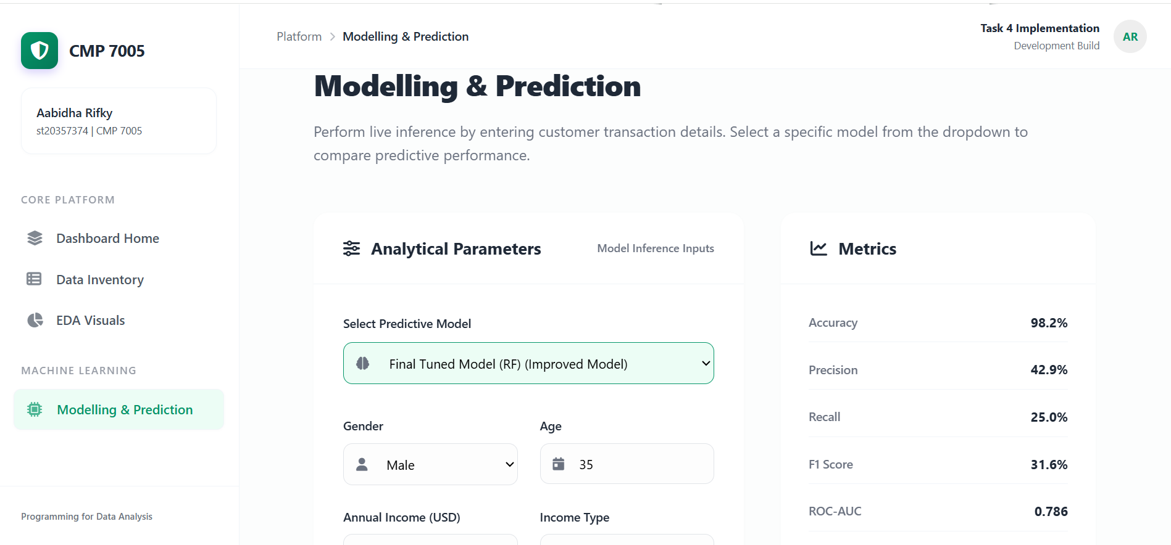
Figure 21 : Prediction page with model selector, input form, and performance metrics panel

Figure 22 : Prediction output showing fraud probability, risk level, and system recommendation
The Flask-based web application serves as a deployment layer that bridges the analytical model with an interactive user interface.
The application follows a modular architecture, where trained models and preprocessing pipelines are loaded directly from saved artefacts generated during the notebook stage. This ensures consistency between offline model evaluation and real-time predictions.
Although multiple models are available within the interface for comparison purposes, the Final Tuned Random Forest is the recommended model for practical use. The inclusion of alternative models enhances transparency and allows users to explore differences in predictive behaviour.
This implementation demonstrates how machine learning models can be operationalised into decision-support tools, which is a key requirement in real-world data analytics systems.

Chapter 7: Version Control and Development Progress

7.1 Version Control and Development Progress
Git and GitHub were used to manage the development of the project from the notebook stage to the Flask application. The repository was organised so that the notebook outputs, saved models, tables, figures, and the web application code were kept in separate areas. This made the project easier to manage and helped show a clearer workflow across analysis and deployment.
The commit history shows that the work was developed in stages rather than uploaded all at once. The recorded commits reflect progress across dataset merging, exploratory analysis, model development, and GUI updates. Commits such as task 1 merging, Task 2 updates, task 3, and GUI changes show that version control was used to track the main parts of the assignment. This was enough to demonstrate steady development progress and satisfy the requirement for Task 5.
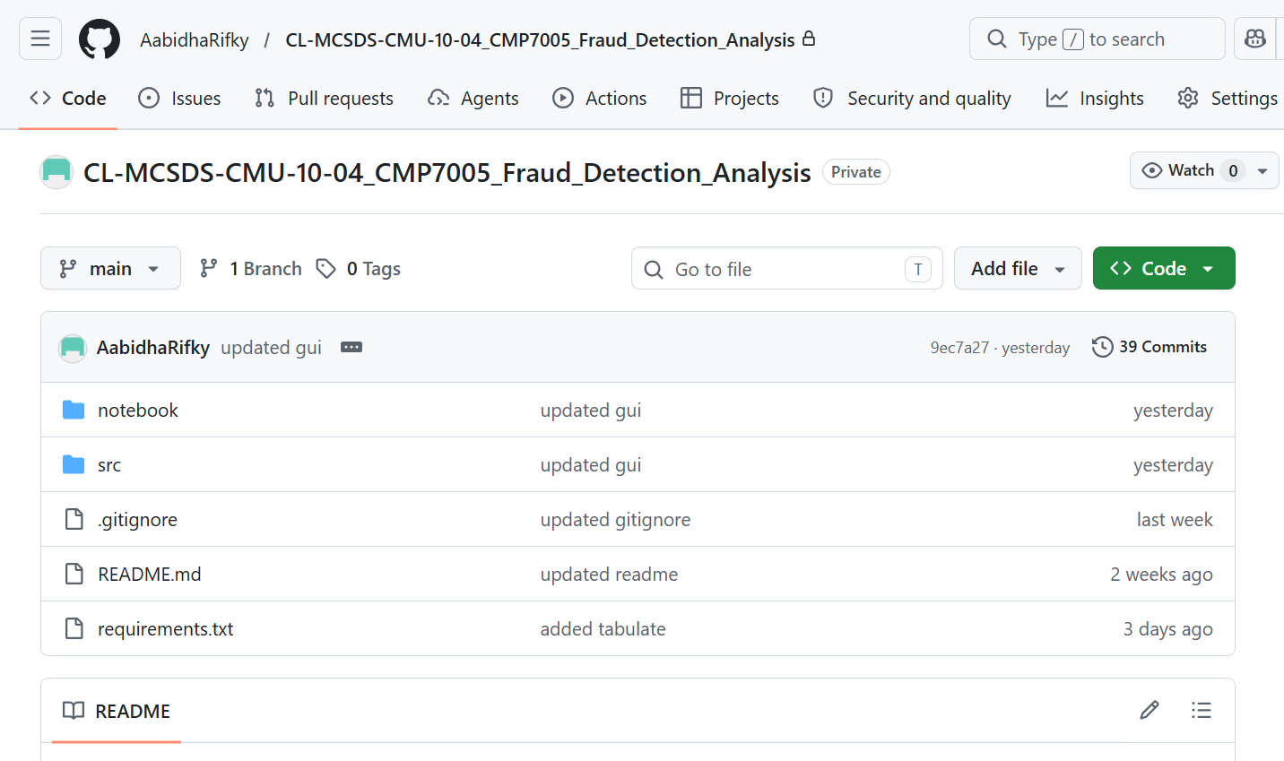
Figure 23 : Git commit history showing the main stages of project development

Chapter 8: Critical Evaluation

8.1 Strengths of the Project
One of the main strengths of the project is that it follows a complete workflow from raw data to deployment. The dataset merge was handled properly, the preprocessing steps were clear, and the missing value problem was small and well managed. The engineered feature INCOME_PER_PERSON also added useful information and later appeared among the stronger variables in the final model. This shows that the feature engineering was not added just for presentation, but actually helped the model.
Another strength is the modelling approach. The notebook compared more than one classifier and did not rely on accuracy alone. The final tuned Random Forest gave the best overall balance for this dataset, especially when compared with Logistic Regression, which produced too many false positives. The project also ended with a working Flask application that could present dataset information, display saved visuals, and generate predictions through a simple interface. This gave the work a practical finish rather than stopping at notebook results only.
The use of model comparison and later threshold tuning was a strong part of the project because imbalanced fraud detection often requires both a suitable classifier and careful decision threshold control (Makki et al., 2019; Zhu et al., 2020; Huang et al., 2024).
Overall, the project demonstrates a strong alignment between data analysis, model development, and deployment, reflecting a complete end-to-end data science workflow.

8.2 Limitations and Practical Considerations
Despite the strong performance of the final model, several limitations must be acknowledged to ensure a realistic interpretation of the results.
The most significant limitation is the severe class imbalance within the dataset, where fraudulent cases represent only a small proportion of the data. This imbalance makes it inherently difficult for the model to learn patterns associated with the minority class, even when techniques such as class weighting are applied (He and Garcia, 2009; Makki et al., 2019). As a result, the model is able to detect only a portion of fraudulent cases, and performance improvements often involve a trade-off between recall and precision.
Although threshold tuning was used to improve the balance between detecting fraud and limiting false positives, this optimisation was conducted during the notebook stage. The deployed web application primarily uses the trained model and stored evaluation metrics, and does not dynamically adjust the classification threshold during live predictions. This creates a gap between offline optimisation and real-time decision-making.
Another limitation relates to feature availability. The dataset lacks temporal and behavioural transaction-level data, such as transaction frequency or sequence patterns, which are commonly used in real-world fraud detection systems. This limitation reduces the model’s ability to generalise to real-world fraud scenarios, where behavioural patterns over time play a critical role in detection accuracy. The absence of these features restricts the model’s ability to capture more complex behavioural anomalies, limiting predictive performance.
From a deployment perspective, the web application simplifies user input by allowing incomplete entries and assigning default values to missing fields. While this improves usability and user experience, it introduces assumptions into the prediction process, which may reduce accuracy when compared to predictions based on fully specified data.
Furthermore, the model has been evaluated on a static dataset. In real-world applications, fraud patterns evolve continuously, meaning that models must be regularly retrained and monitored to maintain effectiveness over time.
Finally, there remains a practical trade-off between false positives and false negatives. Increasing sensitivity improves fraud detection but may also lead to more legitimate transactions being flagged incorrectly. Therefore, the system should be considered a decision-support tool rather than a fully autonomous fraud detection system (Van Vlasselaer et al., 2015).

Chapter 9: Conclusion and Recommendations

9.1 Conclusion
This project successfully developed a complete fraud detection workflow, covering data handling, exploratory analysis, model development, evaluation, and deployment through a Flask-based web application.
The datasets were effectively merged and cleaned, ensuring a reliable analytical foundation. Exploratory Data Analysis provided key insights into feature distributions, relationships, and the severe class imbalance present in the data. The modelling stage demonstrated that ensemble methods, particularly Random Forest, are better suited for this type of problem compared to simpler linear models such as Logistic Regression.
Although Logistic Regression achieved higher recall, its extremely low precision made it impractical for real-world use. In contrast, the Random Forest model provided a more balanced performance, achieving a higher F1-score and better overall predictive stability. Further improvements through hyperparameter tuning and threshold optimisation enhanced the model’s ability to detect fraudulent cases while maintaining acceptable precision.
The results highlight that fraud detection is not driven by a single dominant feature, but rather by complex interactions between financial, demographic, and behavioural variables. This explains why ensemble models outperform linear approaches, as they are better able to capture non-linear relationships within the data.
From a practical perspective, the project also demonstrated how machine learning models can be deployed through an interactive web application. The Flask-based interface allows users to input customer details, select different models, and obtain predictions along with probability scores and risk classifications. This implementation illustrates how analytical models can be translated into real-world decision-support tools.
In real-world fraud detection systems, the cost of failing to detect fraudulent activity is typically much higher than the cost of incorrectly flagging legitimate transactions. Therefore, model performance should be aligned with business objectives. In high-risk environments, decision thresholds may be deliberately lowered to prioritise recall, ensuring that more fraudulent cases are detected even at the expense of increased false positives. This reinforces the importance of threshold tuning as a practical optimisation strategy rather than relying solely on default model outputs.
Overall, this project demonstrates both the technical and practical aspects of fraud detection, highlighting the challenges of working with imbalanced data and the importance of balancing statistical performance with real-world applicability.

Overall, the project demonstrates both the technical implementation and the practical challenges associated with fraud detection in imbalanced datasets. The findings align with existing research, reinforcing the importance of ensemble learning and threshold optimisation. The work highlights the need to balance statistical performance with real-world applicability, particularly in high-risk financial environments.

9.2 Recommendations
Future work could extend this project in several important ways.
Firstly, more advanced techniques for handling class imbalance could be explored, such as SMOTE (Synthetic Minority Over-sampling Technique) or hybrid resampling methods. These approaches may improve recall by generating additional synthetic fraud cases.
Secondly, incorporating temporal and behavioural features would significantly enhance model performance. Real-world fraud detection systems often rely on transaction sequences, frequency patterns, and time-based anomalies, which are not present in the current dataset.
Thirdly, threshold selection could be further refined using cost-sensitive optimisation. Instead of relying solely on F1-score, business-specific cost functions could be used to prioritise fraud detection according to real-world financial impact.
Finally, the web application could be extended to support real-time prediction pipelines, improved input validation, and dynamic threshold adjustment. This would bring the system closer to a production-level fraud detection application.
Future work could also explore explainable AI techniques (XAI) to improve model transparency and trust in decision-making.

REFERENCES
Afriyie, J.K., Tawiah, K., Pels, W.A., Addai-Henne, S., Dwamena, H.A., Owiredu, E.O., Ayeh, S.A. and Eshun, J. (2023) ‘A supervised machine learning algorithm for detecting and predicting fraud in credit card transactions’, *Decision Analytics Journal*, 6, 100163. Available at: https://doi.org/10.1016/j.dajour.2023.100163 (Accessed: 19 April 2026).
He, H. and Garcia, E.A. (2009) ‘Learning from imbalanced data’, *IEEE Transactions on Knowledge and Data Engineering*, 21(9), pp. 1263–1284. Available at: https://doi.org/10.1109/TKDE.2008.239 (Accessed: 18 April 2026).
Huang, H., Liu, B., Xue, X., Cao, J. and Chen, X. (2024) ‘Imbalanced credit card fraud detection data: A solution based on hybrid neural network and clustering-based undersampling technique’, *Applied Soft Computing*, 154, 111368. Available at: https://doi.org/10.1016/j.asoc.2024.111368 (Accessed: 21 April 2026).
Makki, S., Assaghir, Z., Taher, Y., Haque, R., Hacid, M.-S. and Zeineddine, H. (2019) ‘An experimental study with imbalanced classification approaches for credit card fraud detection’, *IEEE Access*, 7, pp. 93010–93022. Available at: https://doi.org/10.1109/ACCESS.2019.2927266 (Accessed: 20 April 2026).
Van Vlasselaer, V., Bravo, C., Caelen, O., Eliassi-Rad, T., Akoglu, L., Snoeck, M. and Baesens, B. (2015) ‘APATE: A novel approach for automated credit card transaction fraud detection using network-based extensions’, *Decision Support Systems*, 75, pp. 38–48. Available at: https://doi.org/10.1016/j.dss.2015.04.013 (Accessed: 17 April 2026).
Zhu, H., Liu, G., Zhou, M., Xie, Y., Abusorrah, A. and Kang, Q. (2020) ‘Optimizing weighted extreme learning machines for imbalanced classification and application to credit card fraud detection’, *Neurocomputing*, 407, pp. 50–62. Available at: https://doi.org/10.1016/j.neucom.2020.04.078 (Accessed: 18 April 2026).

APPENDICES

Appendix A – Additional Model Evidence

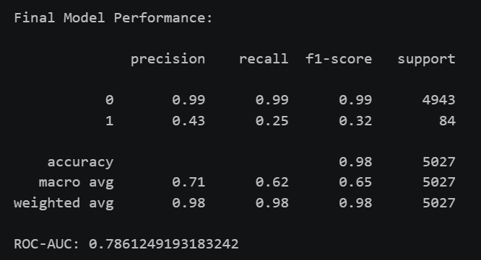
Figure 24 : Classification report for the final tuned model at the default decision threshold

This figure presents the detailed classification report for the final tuned model before threshold adjustment. It shows class-wise precision, recall, F1-score, support, overall accuracy, and ROC-AUC. The results show that the model performed very strongly on the non-fraud class, but fraud detection remained more difficult, with fraud precision of 0.43, recall of 0.25, and F1-score of 0.32. This appendix figure is included to provide deeper model evidence beyond the summary metrics shown in the main chapter.

Appendix B - Confusion matrix for the final tuned model
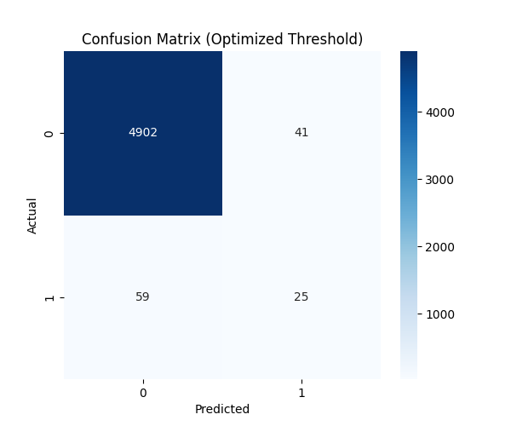
Figure 25 : Confusion matrix for the final tuned model at the optimised threshold (0.44898)
This figure shows the confusion matrix of the final tuned model after threshold optimisation. It indicates that the model correctly classified 4,902 non-fraud cases and 25 fraud cases, while 41 normal cases were incorrectly flagged as fraud and 59 fraud cases were missed. Compared with the default threshold results, this matrix helps show the practical effect of threshold tuning, where the model becomes slightly more sensitive to fraud at the cost of additional false positives. It is included in the appendix as supporting evidence for the model improvement stage.

Appendix C – Github Link
https://github.com/AabidhaRifky/CL-MCSDS-CMU-10-04_CMP7005_Fraud_Detection_Analysis

Appendix D – Onedrive Link
https://icbt-my.sharepoint.com/:f:/g/personal/cl-mcsds-cmu-10-04_student_icbtcampus_edu_lk/IgBou7uqfu-dSanS9C2nPOcHAcsriHnzuWBfajr53w1piNc

